DIE# 15138 – UNITED (EXTRUDER SIDE)
Pack on Green Buggy – Wrap arms in cardboard
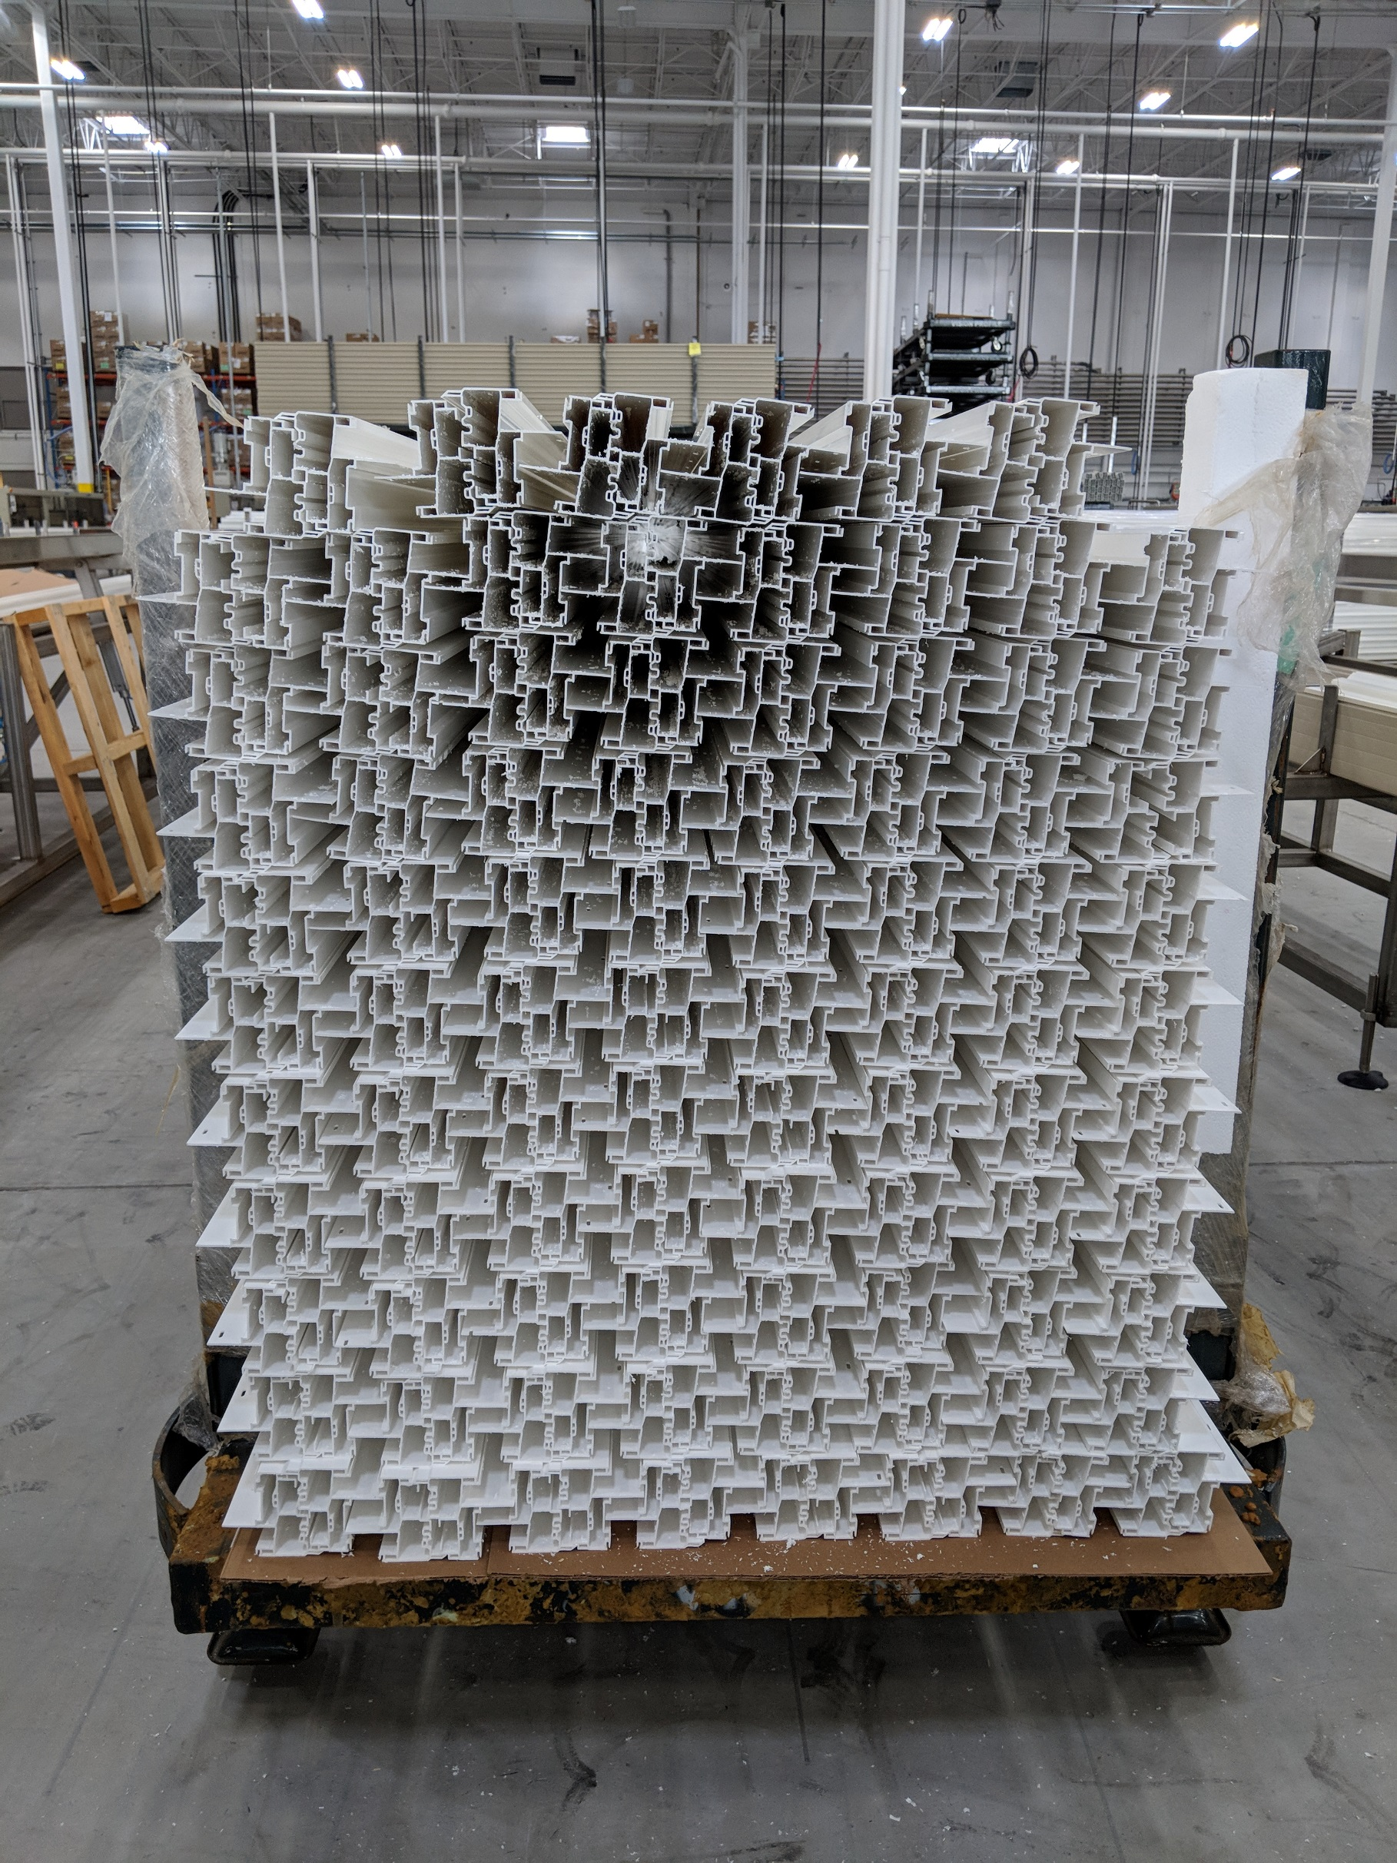
Small Foam on 1 side

